**Comprehensive Guide to Apple iPhone 13 pro: Features, Benefits, and Usage**

# Project Overview

This project aims to create a comprehensive Knowledge Article for the Apple iPhone 13 Pro within the ServiceNow platform. The article will provide detailed information, setup instructions, troubleshooting tips, and accessory details. By integrating this article with the ServiceNow Service Catalog, we aim to improve customer satisfaction, reduce support inquiries, and enhance the overall user experience. The project will involve content creation, knowledge article structuring, Service Catalog integration, testing, and deployment.

# Objectives

**Business Goals:**

1. Lower support costs by reducing the time spent on resolving common issues.
2. Streamline support processes and improve agent productivity.
3. Provide superior customer service by offering self-service options and timely support.
4. Encourage customers to adopt the iPhone 13 Pro by providing comprehensive information and support.
5. Build trust and loyalty by delivering high-quality.

**Specific Outcomes:**

1. Create a detailed Knowledge Article covering all aspects of the iPhone 13 Pro, including features, setup, troubleshooting, and accessories. Ensure the new system works with all current tools.
2. Successfully integrate the Knowledge Article with the iPhone 13 Pro product listing in the Service Catalog. Collect user feedback to improve the system over time.
3. Decrease the number of support tickets related to the iPhone 13 Pro by providing proactive solutions. Create a tool to track how well the system is working.

# Key features and Concepts Utilized

1. Organizing, creating, and sharing information to improve organizational performance.

2. Managing and publishing IT services and products to end-users.

3. Developing clear, concise, and informative content for the Knowledge Article.

4. Writing technical information in a way that is easy to understand for non-technical users.

5. Optimizing the Knowledge Article for search engines to improve visibility.

6. Designing the Knowledge Article with a focus on user-friendliness and readability.

7. Leveraging the ServiceNow platform's capabilities to create, publish, and manage art.

# 4. Detailed steps to solution Design

**Pre-Requisites:-**

1. Knowledge on Service Now Administration.
2. Knowledge on Service catalog.
3. Knowledge on Knowledge Management.

**Skills used to solve the problem statement:-**

1. Service Now Administration.

**Activity 1: Create a New User**

To create a new user in ServiceNow, I accessed the ServiceNow Developer Instance and navigated to the "Users" section under "System Security." I clicked "New" and filled in the necessary details, such as username, password, email, and role. Once the details were filled, I submitted the form to create a new user account in the ServiceNow platform.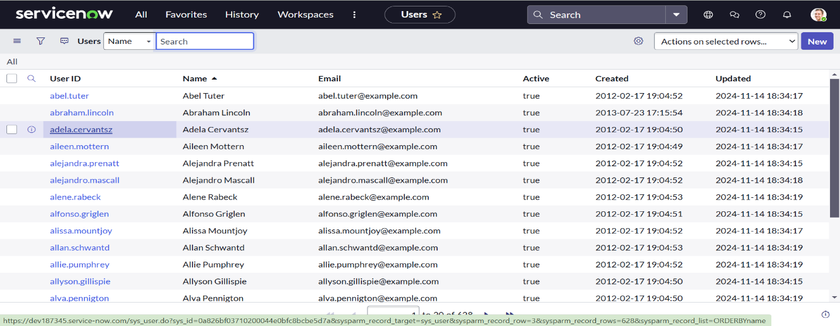.

**Activity 2: Create Users**

To create a new group in ServiceNow, start by accessing the "All" tab and searching for "groups." Select "groups" under "system security." Click "new" to initiate the creation process. Fill in the necessary details for the group. To add "Jai Prakash" as a member of the "Manager Group," click "edit" under "Group Members," add the user, and save the changes.

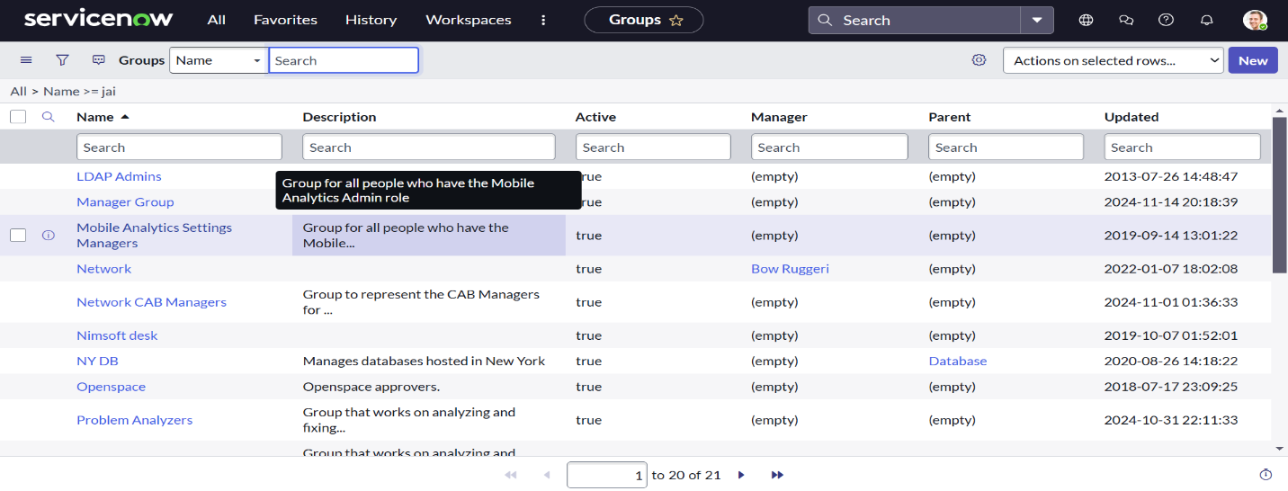

**Activity 3: Create Roles**

To create a new role in ServiceNow, navigate to the "All" tab and search for "roles." Select "roles" under "system security." Click on "new" to initiate the creation process. Fill in the required details for the new role and click "submit" to save it.

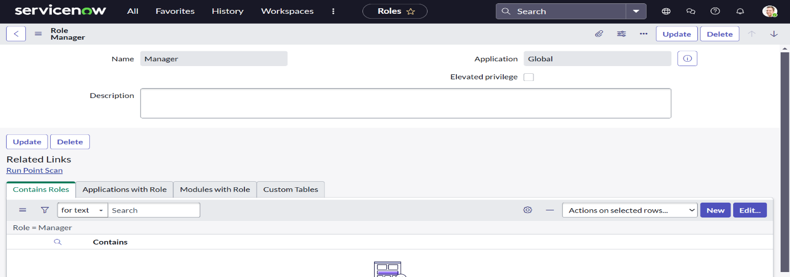

**Activity 4: Creation of Knowledge Base**

To create a new Knowledge Base in ServiceNow, navigate to the "All" tab and search for "Knowledge Bases." Click "New" to initiate the creation process. Fill in the required details: Title as "Mobiles," Owner as "Jai Prakash," and select the appropriate workflows for publishing and retiring. Check the "Active" checkbox and enter the description "The mobiles related Articles will be displayed in this base." Click "Save" and then select an appropriate icon for the Knowledge Base.

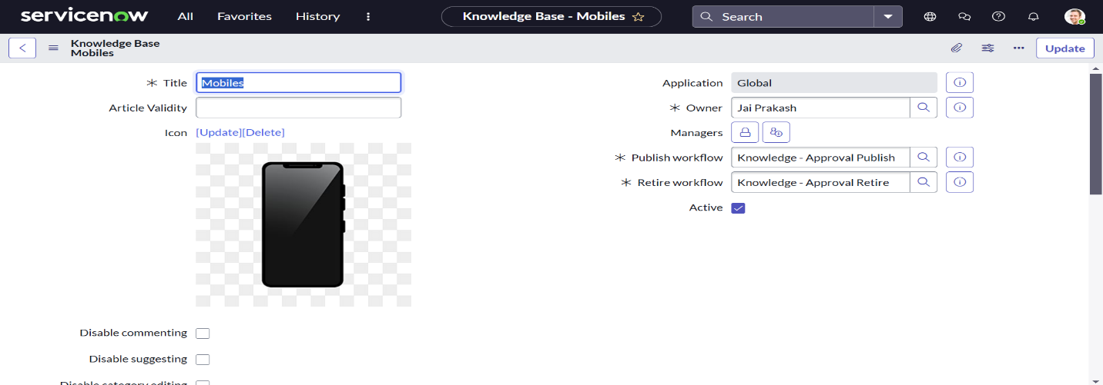

**Activity 5: Creation of Knowledge Article**

To create a new Knowledge Article in ServiceNow, navigate to the "All" tab and search for "Knowledge Article." Click "Create an Article" to initiate the creation process. Select the "Mobiles" Knowledge Base. To add categories, click "Search" and then the "+" icon. Add the desired category pickers and click "OK."

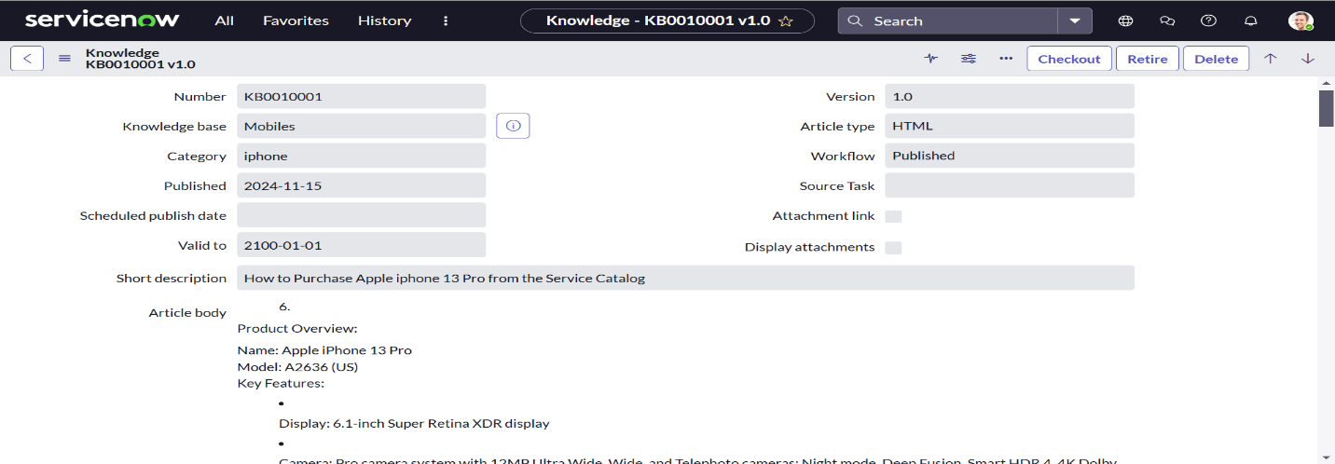

**Activity 6: Linking the Knowledge Article to Catalog item**

To add a related catalog item to a Knowledge Article, start by navigating to the "All" tab and searching for "My Knowledge Article." Open the previously created Knowledge Article. Scroll down to the "Related Catalog Items" section and click "Edit." Add "Apple iPhone 13 Pro" to the list of related catalog items and click "Save" to confirm the changes.

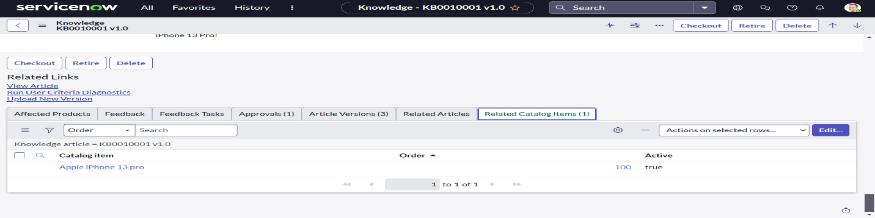

**Activity 7: Approving the Article**

To approve a Knowledge Article, start by navigating to the "All" tab and searching for "My Knowledge Article." Open the previously created Knowledge Article. Scroll down to the "Approvals" section, locate the "Requested" state, and click on it. Change the state to "Approved" and click "Update." Once updated, the Knowledge Article will be in an approved state.

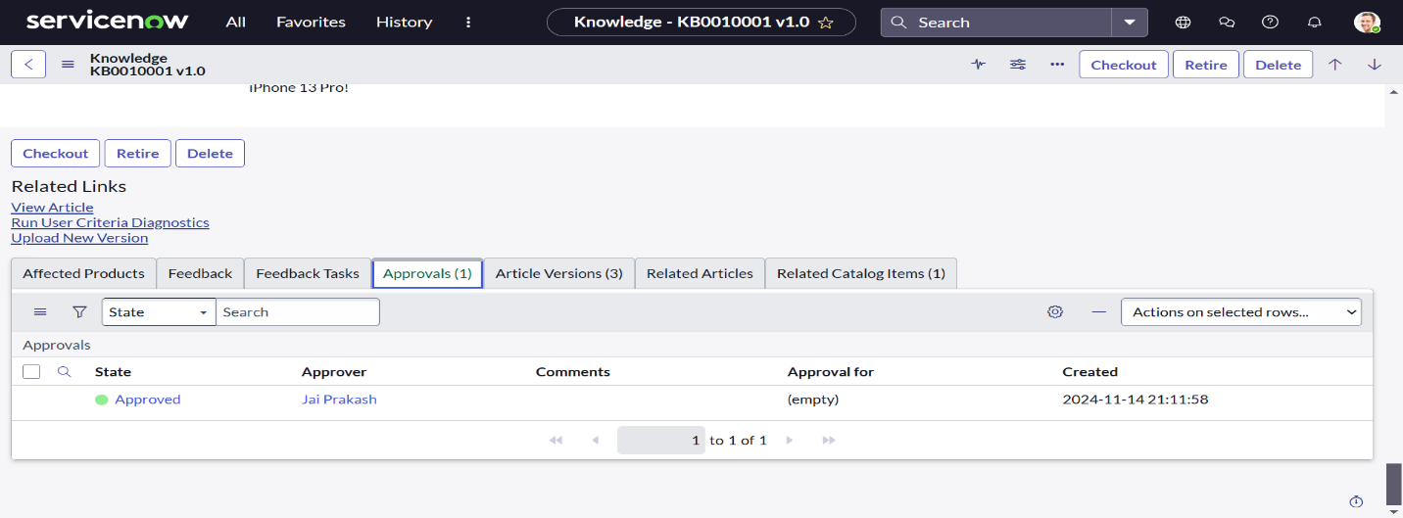

**Activity 8:  Adding Knowledge Base to Service Catalog**

To add a Knowledge Base to a Service Portal, navigate to the "All" tab and search for "Portals." Open "Portals" and then "Service Portal." Scroll down to the "Knowledge Bases" section and click "Edit." Add "Mobiles" to the list of Knowledge Bases and click "Update" to save the changes.

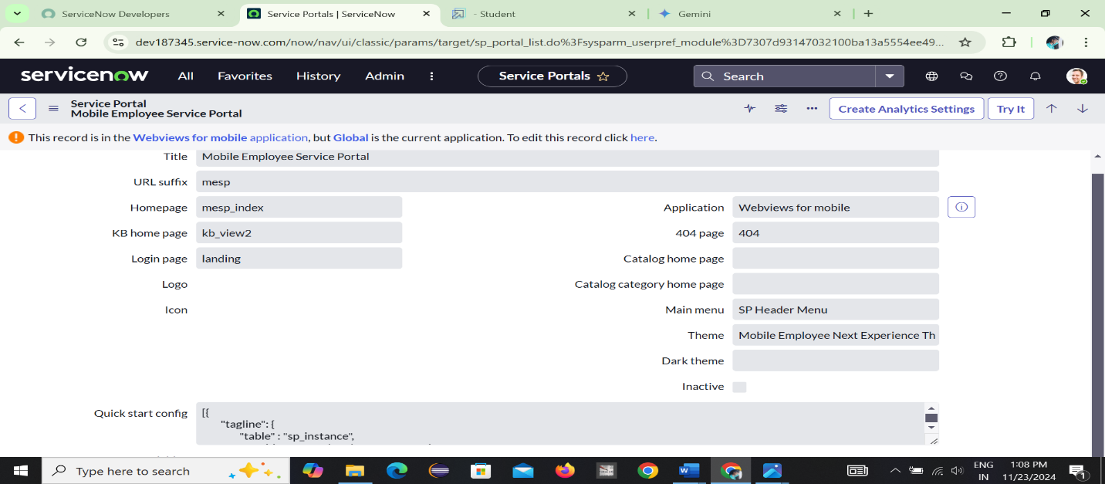

**Conclusion:**

This project successfully implemented a new Knowledge Base in ServiceNow to provide a centralized repository of information related to mobile devices. The Knowledge Base, titled "Mobiles," was created and configured with appropriate workflows and categories. A relevant Knowledge Article was also created and approved, linking it to the "Apple iPhone 13 Pro" as a related catalog item. Finally, the "Mobiles" Knowledge Base was added to the Service Portal, making it accessible to end-users. This project enhances the ServiceNow platform's ability to provide timely and accurate information on mobile devices, improving user experience and streamlining support processes.